**Table Of Content**

Introduction 2

Brief Overview of the Project: 3

Importance of Online Food Ordering Systems: 3

Objectives of the Website Development: 3

Project Overview 2

Explanation of the Three Main Sections of the Application: 2

Explanation of Authentication Levels and User Types: 3

Design Phase 4

Sitemap 4

Wireframe Schematics 4

Development Phase 15

Backend: 18

Database Management 19

Conclusion 22

References 23

# 

# **Introduction**

## Brief Overview of the Project:

* + The project entails the design and development of a food ordering website for a renowned restaurant. The website aims to provide a convenient platform for users to browse available food items, place orders, and for administrators to manage food items and orders effectively. With authentication levels catering to both registered and unregistered users, the website seeks to enhance the overall dining experience by eliminating queue hassles and offering real-time ordering capabilities.

## Importance of Online Food Ordering Systems:

* **Convenience:** Users can order food from the comfort of their homes or on the go, saving time and effort.
* **Choice:** Online platforms offer a wide range of food options from various restaurants, giving users more choices.
* **Efficiency:** Ordering online eliminates the need to wait in long queues, streamlining the ordering process.
* **Real-time Updates:** Users receive real-time updates on order status, ensuring transparency and reliability.
* **Accessibility:** Online food ordering systems are accessible 24/7, allowing users to place orders at their convenience.
  + Overall, online food ordering systems enhance the dining experience by making it more convenient, efficient, and accessible for users.

## Objectives of the Website Development:

* + The primary objectives of developing the food ordering website are as follows:
* **Provide Information and Exploration:** Offer essential information about food items, including prices, descriptions, and images, to help users make informed choices.
* **Facilitate Food Ordering:** Enable users to order food items with ease by allowing them to select items, specify quantities, and add them to a cart for checkout.
* **Admin Control:** Empower restaurant administrators with a comprehensive admin panel to manage food items, track orders, and update order statuses.
* **Authentication Levels:** Implement different authentication levels (admin, registered user, unregistered user) to ensure secure access and appropriate permissions for different user types.
* **Database Management:** Develop a robust database system to store food item details, user accounts, and order records efficiently.
* **User-Friendly Interface:** Design an attractive and intuitive user interface that enhances the overall user experience and encourages user engagement.

# Project Overview

The restaurant's requirements for the food ordering website would include:

* **Efficient Ordering Process:** The restaurant would require a seamless online ordering system to handle a potentially high volume of orders efficiently.
* **Menu Management:** It needs a platform where administrators can easily add, update, and remove food items as per availability and seasonal changes.
* **Customer Engagement:** The website should provide an engaging experience for customers, showcasing enticing images and detailed descriptions of food items to encourage orders.
* **Order Management:** The restaurant needs a robust system to manage orders effectively, including order tracking, status updates, and communication with customers.
* **Security and Privacy:** With the handling of customer data and transactions, security measures are paramount to protect sensitive information and ensure customer privacy. (Harun & Yusof, 2014)

## Explanation of the Three Main Sections of the Application:

* **Food Items Information & Exploration:** This section provides detailed information about the restaurant's food items, including their names, descriptions, prices, and images. It serves as a virtual menu for users to explore before placing an order.
* **Food Ordering:** In this section, users can select desired food items, specify quantities, and add them to their cart for checkout. It facilitates the ordering process by allowing users to review their selections before finalizing their orders.
* **Admin Panel:** The admin panel is a backend interface for restaurant administrators to manage the application effectively. It includes functionalities such as adding, updating, and removing food items from the menu, tracking orders, and managing user accounts. Admins can also approve orders and update their status as needed.

## Explanation of Authentication Levels and User Types:

**Authentication Levels:**

* + **Admin:** Administrators of the restaurant have full control over the application. They can access the admin panel to manage food items, orders, and user accounts.
  + **Guest Users:** There are two types of guest users:
    - **Registered:** Users who have created an account on the website can log in to access additional features such as order history and saved preferences.
    - **Unregistered:** Users who visit the website without logging in can still browse food items but cannot place orders until they create an account. (Influencer Marketing Hub, 2024)

**User Types:**

* + **Admin:** Restaurant administrators responsible for managing the website and overseeing its operations.
  + **Registered User:** Individuals who have created an account on the website to enjoy personalized features and benefits.
  + **Unregistered User:** Visitors who access the website without creating an account. They have limited access to features and cannot place orders until they register.

# **Design Phase**

## Sitemap

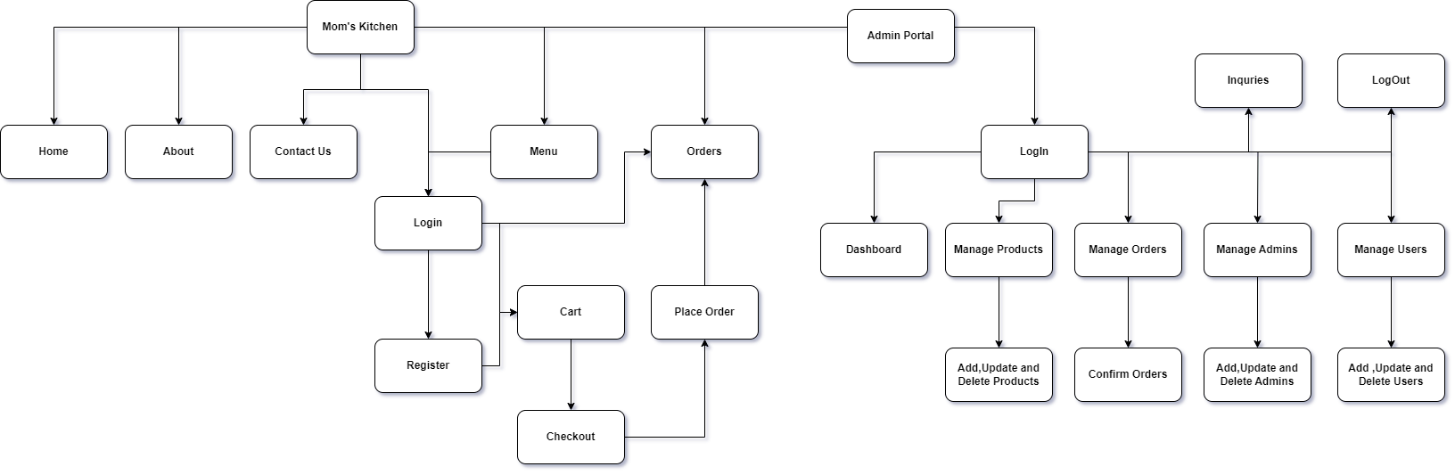***SiteMap***

* + - Description of the website's structure and navigation flow
    - Illustration of the sitemap

## Wireframe Schematics

* + - Overview of the wireframes for key pages (home, food items, cart, admin panel, etc.)
    - Detailed description of each wireframe
    - Justification for design choices

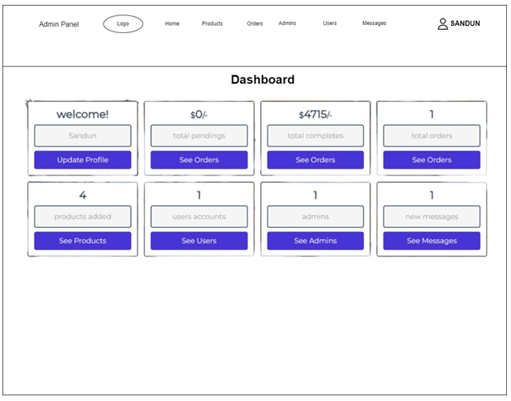

• **Dashboard:** This section provides an overview of the important metrics of the website. In the image, it shows:

* Welcome message with username
* Total Earnings for the day
* Total Pending Orders
* Today’s Total Orders

• **Quick Links:** These are buttons that allow the admin to access different sections of the panel quickly. Here, the links are:

* See Products
* See Orders
* See Users
* See Admins
* See Messages

• **Stats** These are boxes that display the number of entities related to that section. Here it shows:

* Products Added
* User Accounts
* Admins
* New Messages

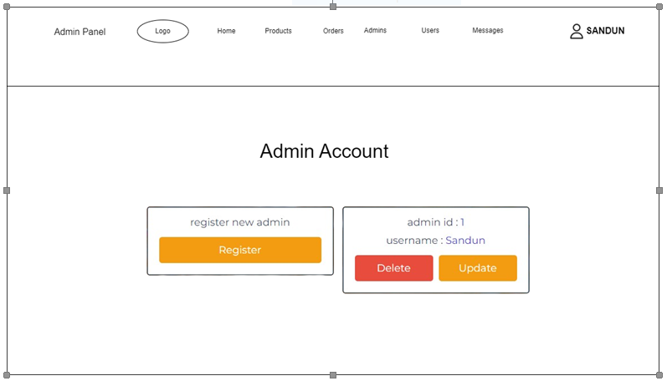

the wireframe seems to provide a basic layout for an admin panel that allows website administrators to manage various aspects of a website, including user accounts, products, orders and potentially other website content.

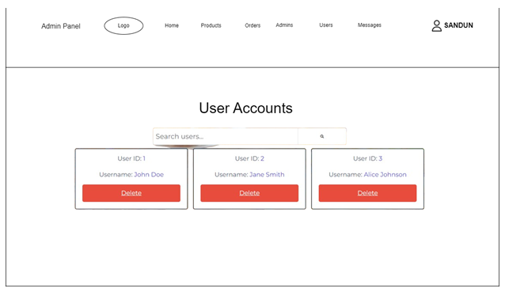

This section of the website’s admin panel appears to allow administrators to view a list of user accounts and potentially search for specific users. It’s likely that other parts of the admin panel would allow admins to edit user account information or create new user accounts.

**Users** section which appears to be the main content area of this page. It contains information about user accounts and potentially some options for managing them. Here’s what we can see about user accounts in this section:

* **Search users** bar at the top, which may allow admins to search for users by username or other criteria.
* A table with a header row containing the following columns:
  + User ID
  + Username
  + Delete (presumably a button to delete the user account)

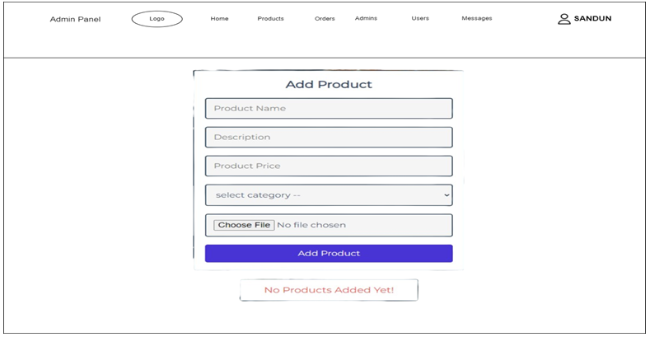

This section of the website’s admin panel appears to allow administrators to add new products to the website.

• **Add Product** section which appears to be the main content area of this page. It contains a form that allows admins to add new products to the website’s catalog. Here are the form fields visible in this section:

* **Product Name**
* **Description**
* **Product Price**
* **Select Category** (dropdown menu)
* **Choose File** (file upload button)

• **Add Product** button, which would likely submit the form and add the new product to the website’s catalog.

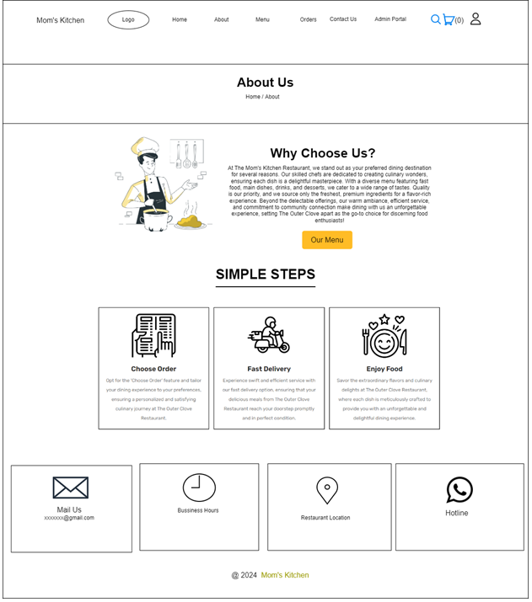

The website also mentions that they have a simple ordering process with online choices for ordering, fast delivery, and enjoying the food.

Overall, the website is designed to persuade users to choose Mom's Kitchen as their restaurant of choice. They emphasize the quality of the food, the variety of the menu, and the positive dining experience they offer.

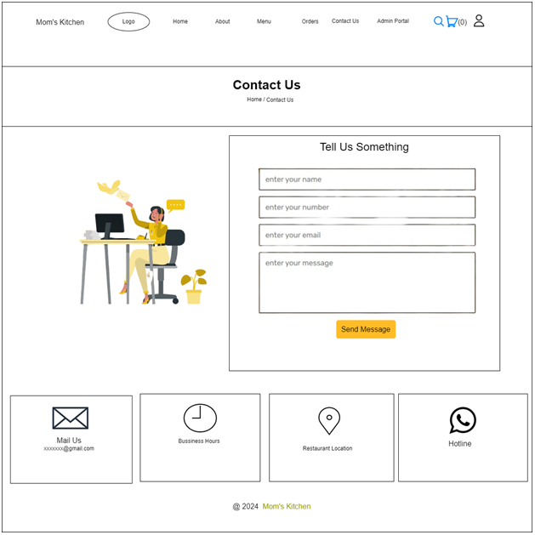

This is a contact us page that allows users to send a message to Mom's Kitchen.

• There is a text **Tell Us Something**

• There are four more text boxes where users can enter their contact information:

* **Enter your name**
* **Enter your number**
* **Enter your email**
* **Enter your message**

• There is a button labeled **Send Message** which would presumably allow the user to submit the contact form

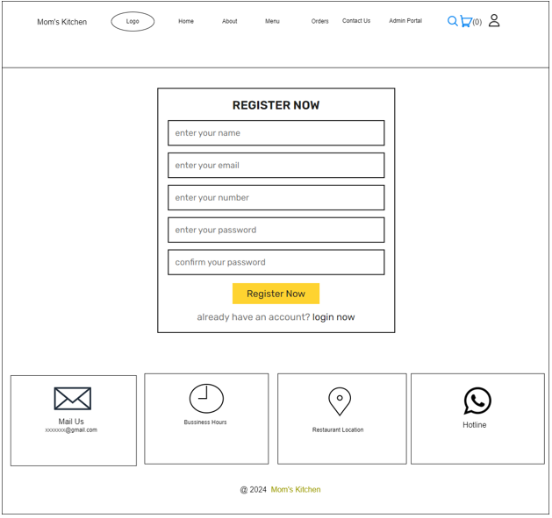

• **Register Now** is the main heading at the top of the page

• There are three text boxes where users can enter their contact information:

* **Enter your name**
* **Enter your email**
* **Enter your number**

• There are two text boxes where users can create a password:

* **Enter your password**
* **Confirm your password** (to ensure they typed the password correctly)

• There is a button **Register Now** which would presumably allow the user to submit the signup form and create a new account

• Below the signup form, there is a question **Already have an account?** with a link to the login page: **Login Now**

this signup page allows users to create an account on the Mom's Kitchen website. Once they create an account, they may be able to access features that are available to non-registered users, such as online ordering or exclusive promotions.

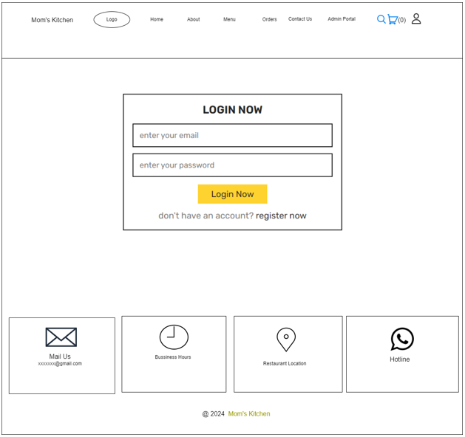

This login page allows registered users of Mom's Kitchen to sign in to their account. Once logged in, they may be able to access features that are not available to non-registered users, such as online ordering or exclusive promotions.

* **Login Now** is the main heading at the top of the page
* There are two text boxes where users can enter their login credentials:
  + **Enter your email**
  + **Enter your password**
* There is a button labeled **Login Now** which would presumably allow the user to submit the login form and access their account
* Below the login form, there is a question **Don't have an account?** with a link to the signup page: **Register Now**

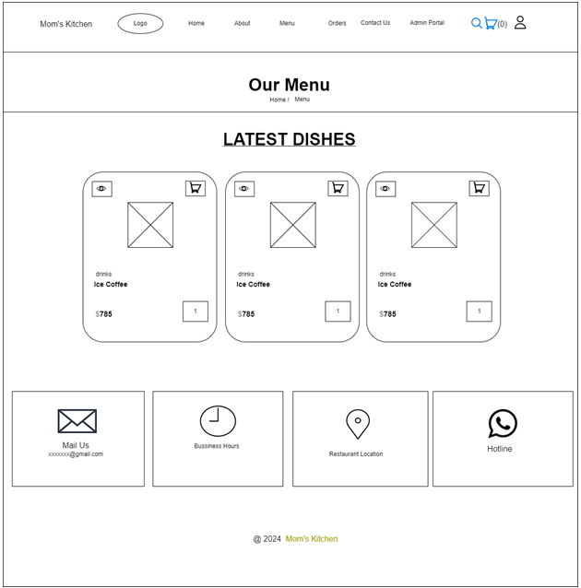

The main content area contains the restaurant's menu. Here's what we can see about the menu:

* **Our Menu** is a heading at the top of the menu
* **Latest Dishes** is a subheading above the first menu items
* There is one menu item listed under "Latest Dishes"

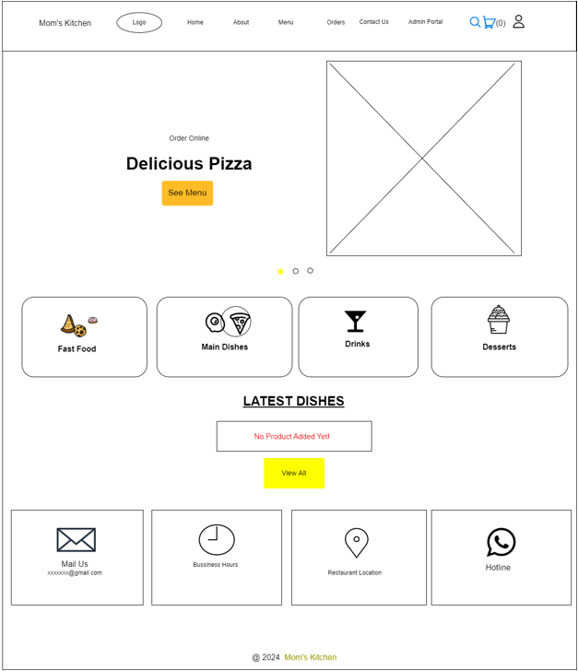

## **Development Phase**

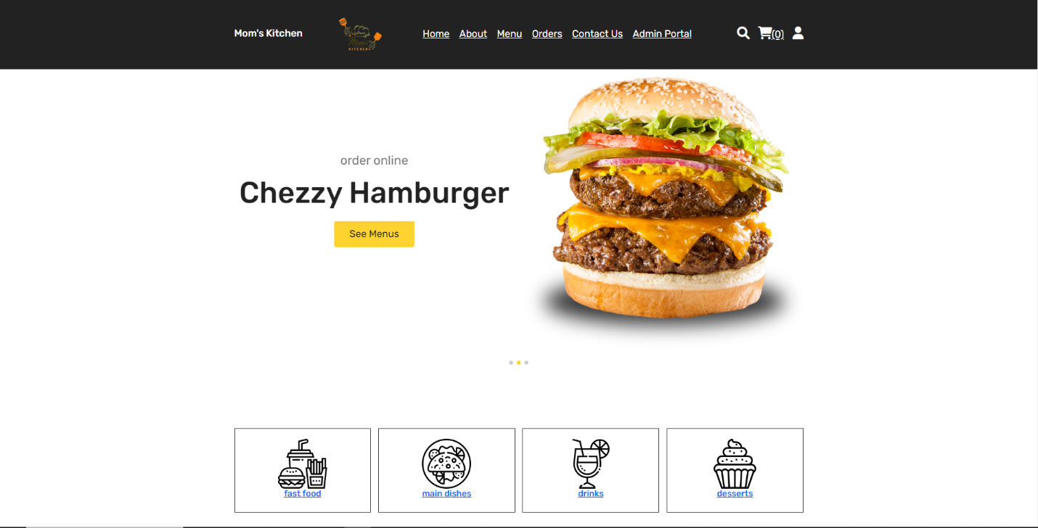***User HomePage***

This PHP script generates a dynamic webpage for "Mom's Kitchen" a food-related website. The page begins with a header section, presumably featuring branding and navigation links, setting the stage for an immersive user experience. Following this, a visually striking hero section captures attention with a slider showcasing tantalizing images of different food items alongside captivating captions, inviting users to explore and order online.

Continuing down the page, users encounter a categorized section presenting various food options, each accompanied by an enticing image and a clickable link directing them to explore specific categories further. As users scroll, they're greeted with the latest dishes section, where a grid layout showcases mouthwatering products. Each product box includes an image, name, category, price, and interactive elements allowing users to add items to their cart or view quick details. The page wraps up with a footer section, offering additional navigation or contact options, ensuring a cohesive and user-centric browsing experience. With its blend of visually appealing design, interactive features, and seamless navigation, the webpage provides a compelling platform for users to explore and indulge in the culinary offerings of " Mom's Kitchen " (Stack Overflow, 2024)

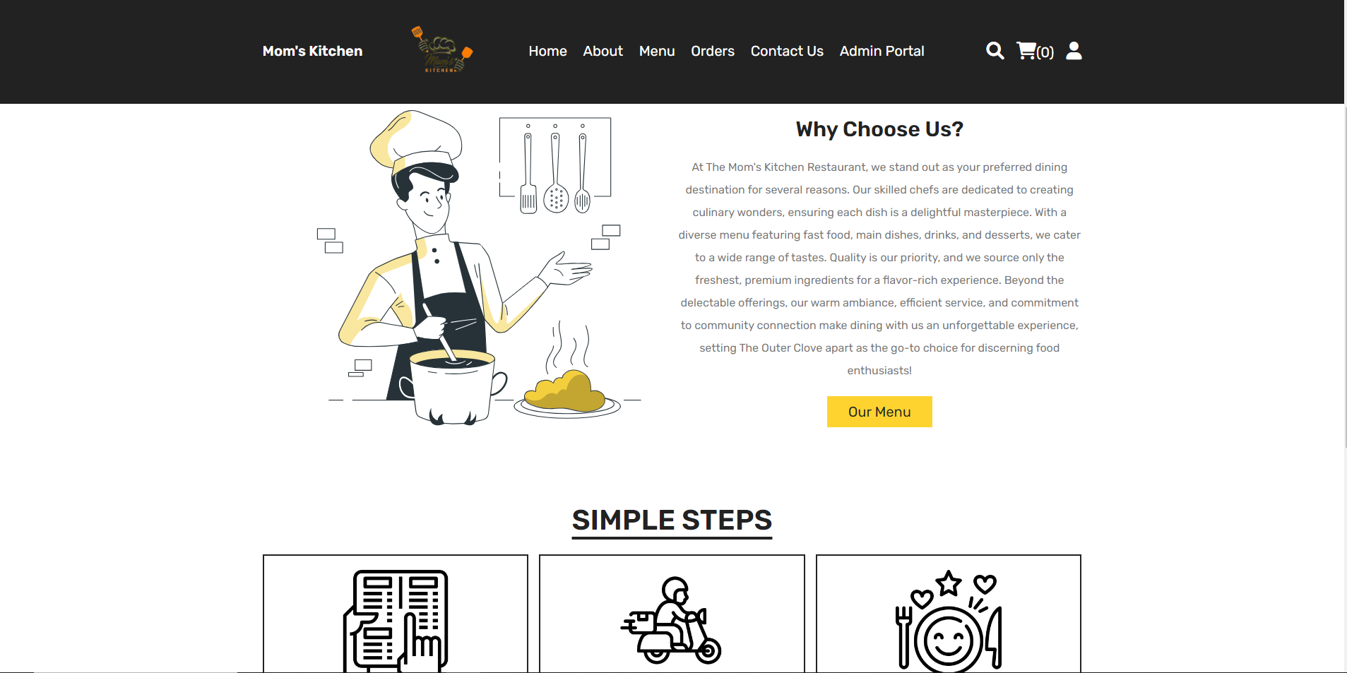***User AboutUs Page***

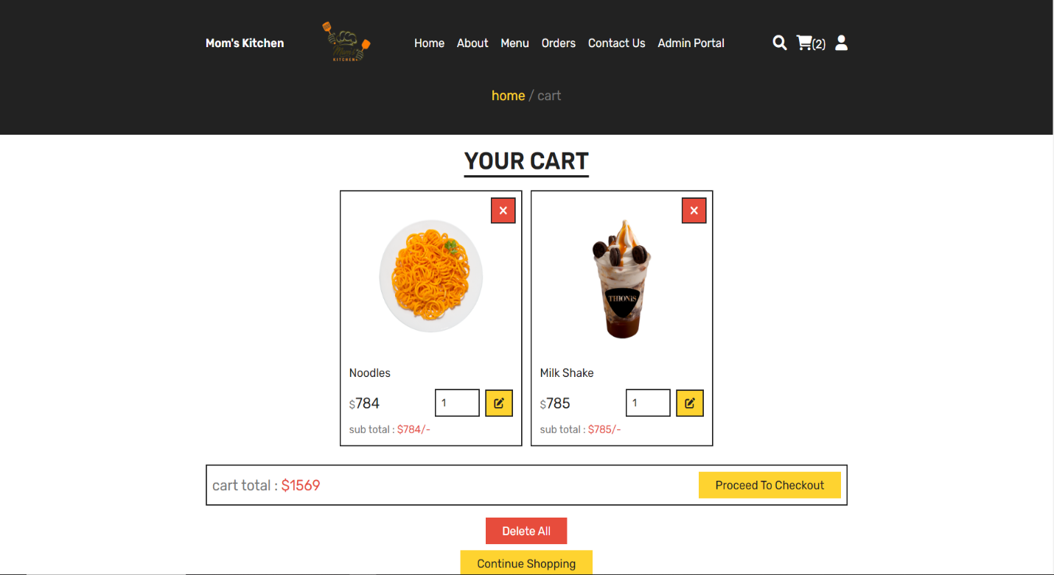***User CheckoutPage***

This PHP script powers the "Cart" page for a food-related website, offering users a seamless shopping experience. Upon accessing the page, users are directed to their shopping cart, provided they are logged in. If not, they are redirected to the home page for authentication.

The page is structured to display a list of items added to the cart, each presented within a distinct box. Users can view details of each item, such as its image, name, price, and quantity, along with the option to adjust quantities or remove items entirely. Interaction is facilitated through intuitive icons for actions like viewing, deleting, or updating quantities, enhancing user control and convenience.

Furthermore, the page dynamically calculates the subtotal for each item and the overall cart total, contributing to a transparent shopping experience. Users are prompted with a "proceed to checkout" button once items are added, guiding them towards completing their purchase. Additionally, functionality is provided to clear the entire cart or continue shopping, ensuring flexibility and ease of use. With its user-centric design and robust functionality, the "Cart" page serves as a pivotal component in streamlining the online shopping journey for users of the website. (Quora, 2024)

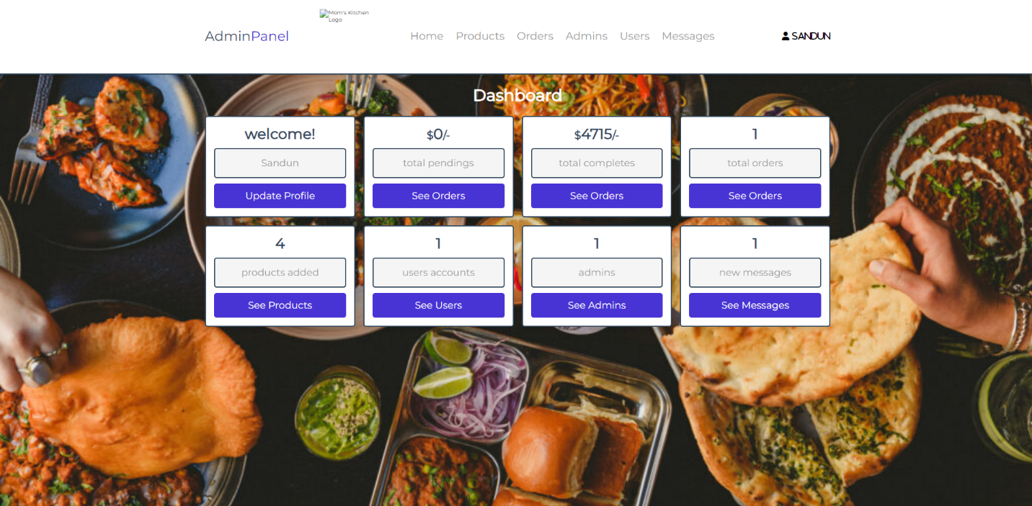***Admin Dashboard***

This PHP script serves as the backend logic for the admin dashboard of a food-related website. It begins by including the necessary connection to the database and starting a session to authenticate the admin user. If the session variable "admin_id" is not set, the user is redirected to the admin login page for authentication.

Moving to the front-end functionalities, the dashboard section dynamically presents various statistics and options for the admin. It displays essential information such as the admin's name, total pending orders, total completed orders, total orders overall, total products added, total user accounts, total admin accounts, and new messages received. Each statistic is presented within a distinct box, offering clarity and ease of navigation for the admin.

Furthermore, the front end provides actionable buttons allowing the admin to update their profile, view placed orders, manage products, access user accounts, handle admin accounts, and check messages. These buttons are strategically placed alongside each statistic, enabling efficient navigation and management of the website's backend functionalities. With its intuitive design and comprehensive statistics, the admin dashboard serves as a central hub for overseeing and managing various aspects of the website's operations.

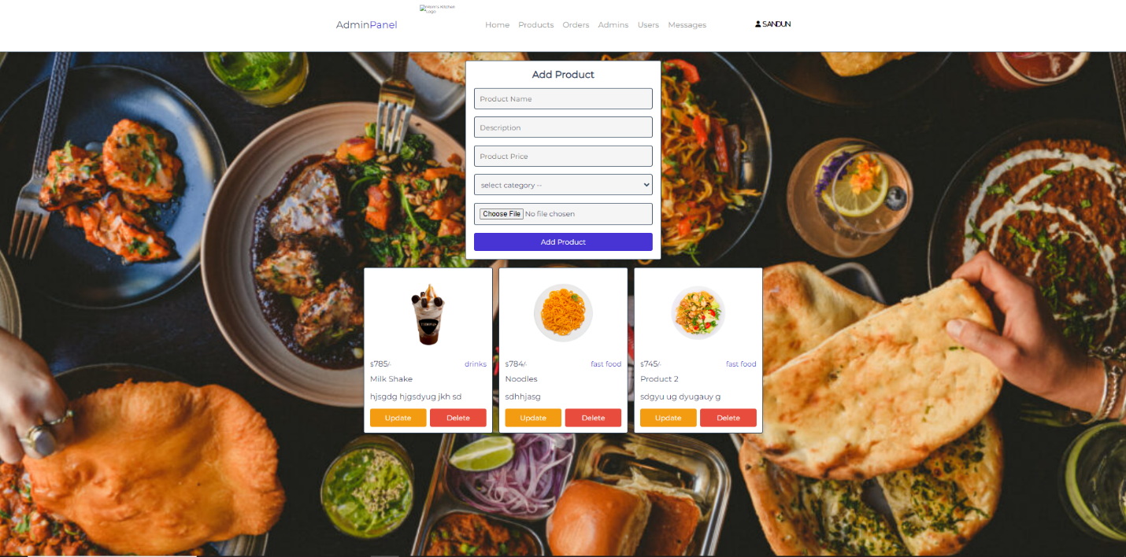***Admin Add_ProductPage***

## **Backend:**

1. **PHP Processing**:
   * **Session Handling**: Sessions are used to keep track of admin login status. If an admin is not logged in, they are redirected to the login page.
   * **Form Submission Handling**: When the "add product" form is submitted (**$_POST['add_product']**), the PHP code processes the form data.
   * **Data Sanitization**: Input data such as name, description, price, and category are sanitized using **filter_var()** to prevent SQL injection and other security vulnerabilities.
   * **File Upload Handling**: The image file uploaded by the admin is processed. If the file size is within limits (2MB in this case), it's moved to the appropriate folder (**../uploaded_img/**).
   * **Database Interaction**: The PHP code interacts with the database using PDO (PHP Data Objects). It prepares and executes SQL queries to insert new products (**INSERT INTO**) and delete existing products (**DELETE FROM**).
   * **Error Handling**: If there are any errors during the process (e.g., duplicate product name, large image size), appropriate error messages are displayed.
2. **Database**: The application interacts with a database (presumably MySQL or similar) to store and retrieve product information.
3. **Security Measures**:
   * **Session Management**: Sessions are used for authentication, ensuring that only logged-in admins can access the admin panel.
   * **Data Sanitization**: Input data is sanitized to prevent SQL injection attacks.
   * **File Upload Security**: File uploads are validated to ensure they are of the correct type and size. (InvoZone, 2023)

# **Database Management**

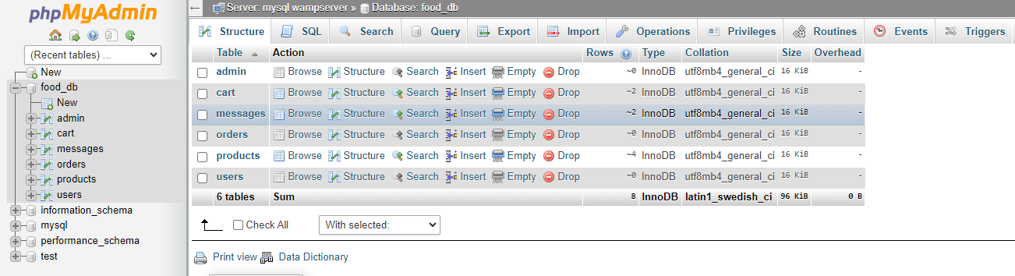

**Table: admin**:

* + This table stores information about administrators who can manage the system.
  + Fields: **id** (unique identifier), **name** (admin's name), **password** (hashed password).
  + The **id** field is the primary key, and it auto-increments.

**Table: cart**:

* + This table holds items added to the cart by users.
  + Fields: **id** (unique identifier), **user_id** (identifier of the user who added the item), **pid** (product ID), **name** (name of the product), **price** (price of the product), **quantity** (quantity of the product), **image** (image filename of the product).
  + The **id** field is the primary key, and it auto-increments.

**Table: messages**:

* + This table stores messages sent by users.
  + Fields: **id** (unique identifier), **user_id** (identifier of the user who sent the message), **name** (sender's name), **email** (sender's email), **number** (sender's contact number), **message** (message content).
  + The **id** field is the primary key, and it auto-increments.

**Table: orders**:

* + This table records placed orders.
  + Fields: **id** (unique identifier), **user_id** (identifier of the user who placed the order), **name** (user's name), **number** (user's contact number), **email** (user's email), **method** (payment method), **address** (delivery address), **total_products** (list of products ordered), **total_price** (total price of the order), **placed_on** (date and time of order placement), **payment_status** (status of payment, default is 'pending').
  + The **id** field is the primary key, and it auto-increments.

**Table: products**:

* + This table contains information about available products.
  + Fields: **id** (unique identifier), **name** (product name), **category** (product category), **price** (product price), **image** (image filename of the product).
  + The **id** field is the primary key, and it auto-increments.

**Table: users**:

* + This table stores information about registered users.
  + Fields: **id** (unique identifier), **name** (user's name), **email** (user's email), **number** (user's contact number), **password** (hashed password), **address** (user's address).
  + The **id** field is the primary key, and it auto-increments.

Each table is properly indexed with a primary key to ensure efficient querying, and the **AUTO_INCREMENT** property ensures that primary key values are automatically generated for new records. Additionally, the tables use the InnoDB storage engine, which provides support for transactions and foreign key constraints. Overall, these tables form the backbone of the food ordering system, allowing for the management of administrators, users, products, carts, messages, and orders.

(Techopedia, 2024)

# **Conclusion**

"Mom's Kitchen" has crafted an exemplary food ordering system that stands out for its user-centric design and intuitive functionality. The heart of this system lies in its meticulously curated menu slide interface, which serves as the gateway to a delightful culinary journey for customers.

At first glance, the menu slide warmly welcomes users with its inviting layout, reminiscent of the comforting ambiance of a home kitchen. Through thoughtful categorization, ranging from appetizers to main courses and desserts, navigating the extensive array of offerings becomes a breeze. Each category unfolds seamlessly, revealing tantalizing descriptions accompanied by vivid imagery, enticing customers to explore further.

What distinguishes "Mom's Kitchen" is its emphasis on interactive features that empower users to tailor their dining experience to their preferences. Within the menu slide, customers can dive deeper into each item, discovering nuanced details and customization options. Whether it's selecting preferred toppings, specifying dietary preferences, or adjusting portion sizes, the system accommodates every whim with grace and flexibility.

A standout feature of "Mom's Kitchen" is its commitment to inclusivity and accessibility. The menu slide's search functionality enables swift exploration, catering to customers with specific cravings or dietary requirements. Moreover, the system's responsive design ensures a seamless transition across devices, whether accessing from a desktop, tablet, or smartphone, reaffirming the brand's dedication to serving customers wherever they are.

# **References**

1. Dataversity. (2022). *What is Database Management?* Retrieved from <https://www.dataversity.net/what-is-database-management/>(Accessed May 10, 2024)
2. Harun, A., & Yusof, Z. (2014*). A review on restaurant reservation, marketing and management systems from diners' perspective. Information Systems, 44, 57-67.* <https://www.sciencedirect.com/science/article/pii/S0925527314002850>(Accessed May 7, 2024)
3. Influencer Marketing Hub. (2024). *Levels of Authentication. Retrieved from* <https://influencermarketinghub.com/glossary/levels-of-authentication/>(Accessed May 7, 2024)
4. InvoZone. (2023). *How to Make a Backend for a Website.* Retrieved from <https://invozone.com/blog/how-to-make-backend-for-website/>(Accessed May 8, 2024)
5. LoginTC. (2024). *Types of Authentication. Retrieved from* <https://www.logintc.com/types-of-authentication/>(Accessed May 11, 2024)
6. Quora. (2024). *I am building a website from scratch for a client using HTML, CSS, and JavaScript. They want to add an online store. Without WordPress, Shopify, etc., is there any way for me to add this e-commerce functionality without?* Retrieved from <https://www.quora.com/I-am-building-a-website-from-scratch-for-a-client-using-HTML-CSS-and-JavaScript-They-want-to-add-an-online-store-Without-WordPress-Shopify-etc-is-there-any-way-for-me-to-to-add-this-ecommerce-functionality-without>(Accessed May 8, 2024)
7. Revfine. (2024). *Online Food Ordering System.* Retrieved from <https://www.revfine.com/page/guest-journey-template/> (Accessed May 7, 2024)
8. Stack Overflow. (2024). *How to Generate a HTML Page Dynamically Using PHP*. Retrieved from <https://stackoverflow.com/questions/14871014/how-to-generate-a-html-page-dynamically-using-php>(Accessed May 8, 2024)
9. Techopedia. (2024)*. Database Management Systems (DBMS).* Retrieved from <https://www.techopedia.com/definition/24361/database-management-systems-dbms>(Accessed May 9, 2024)